-----PART A-------

-----PART B------

select movie_name, release_date from movies

select first_name, last_name from directors where nationality = 'American'

select *from actors where gender='M' AND date_of_birth > '1970-01-01'

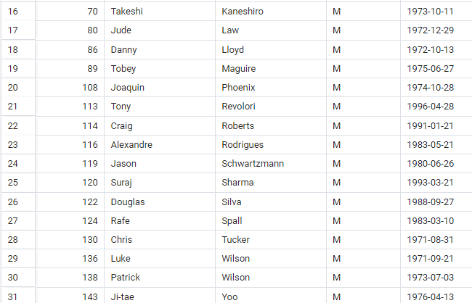

select movie_name from movies WHERE movie_length>90 AND movie_lang ='English'

---Part C---

select first_name, last_name from actors WHERE last_name like 'M%' AND date_of_birth BETWEEN '1940-01-01' AND '1969-12-31'

select first_name , last_name from directors WHERE nationality IN ('British', 'French','German') AND date_of_birth BETWEEN '1950-01-01' AND '1980-12-31'

